

📊 Junior Data Analyst | Excel • SQL • Power BI • Python
I enjoy exploring data, finding patterns, and turning raw information into clear, actionable insights that support better decisions.

--- ## 👨‍💻 About Me - 🔎 Aspiring data professional who enjoys turning data into useful insights. - 📈 Interested in data cleaning, exploratory data analysis, dashboards, and reporting. - 🧰 Working with **Excel, SQL, Power BI, and Python**. - 🌱 Continuously improving my analytical, visualization, and problem-solving skills. - 🤝 Open to collaborating on beginner-friendly data analytics projects. --- ## 🛠️ Skills & Tools
| Tool | What I use it for | |---|---| | | Data cleaning, formulas, PivotTables, charts, reports | | | Filtering, joins, aggregations, subqueries, data analysis | | | Interactive dashboards, KPIs, data modeling, DAX | | | Data analysis and automation | | | Data manipulation and analysis *(as applicable)* | | | Notebooks and exploratory analysis *(as applicable)* |
--- ## 📂 Featured Projects > Replace these examples with your actual repositories when they are ready. Don't link to projects you haven't published yet.
📊 Sales Analysis Dashboard  Analyze revenue, profit, product performance, and sales trends with an interactive dashboard.  Tools: Power BI, Excel   | 🗃️ SQL Business Analysis  Answer business questions using joins, aggregations, subqueries, and window functions.  Tools: SQL
🐍 Exploratory Data Analysis  Clean a dataset, explore distributions and relationships, and communicate key findings.  Tools: Python, Pandas, Matplotlib | 📑 Excel Reporting  Build a clean reporting workbook with formulas, PivotTables, charts, and useful summaries.  Tools: Excel
--- ## 📊 GitHub Stats
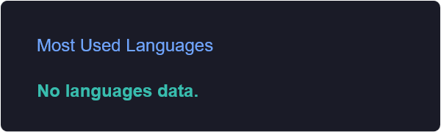
--- ## 🎯 Current Goals - Build practical projects using real-world datasets. - Improve SQL querying and Python data analysis. - Create clear, interactive Power BI dashboards. - Share projects with well-documented findings and recommendations. --- ## 🤝 Let's Connect

“Without data, you're just another person with an opinion.”


